Impressionen aus dem IIMC während der Covid-19 Pandemie
aufgenommen im April und Mai 2020

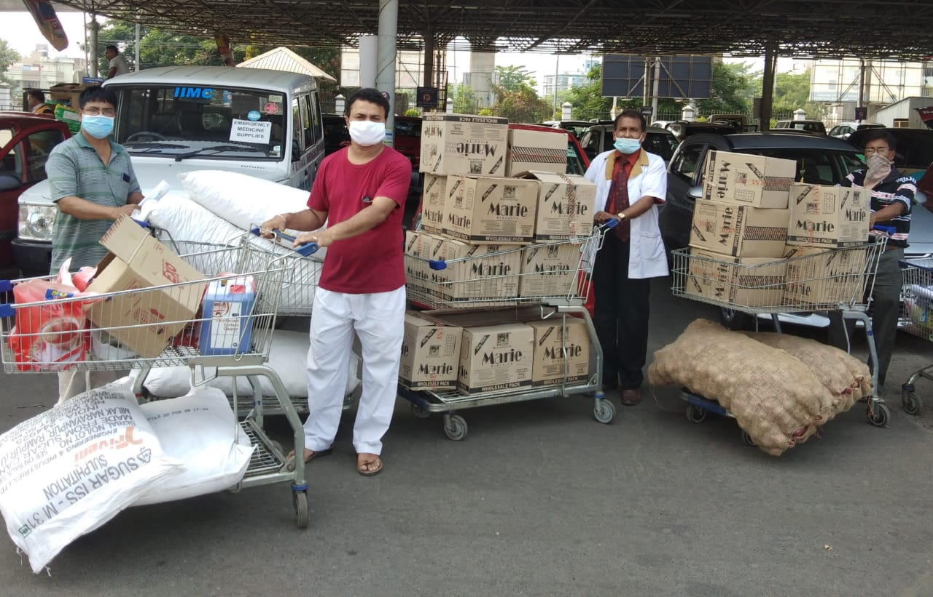  Dr. Sujit und sein Team (IIMC-Mitarbeiter und Freiwillige) beim Einkaufen von Nahrungsmitteln | 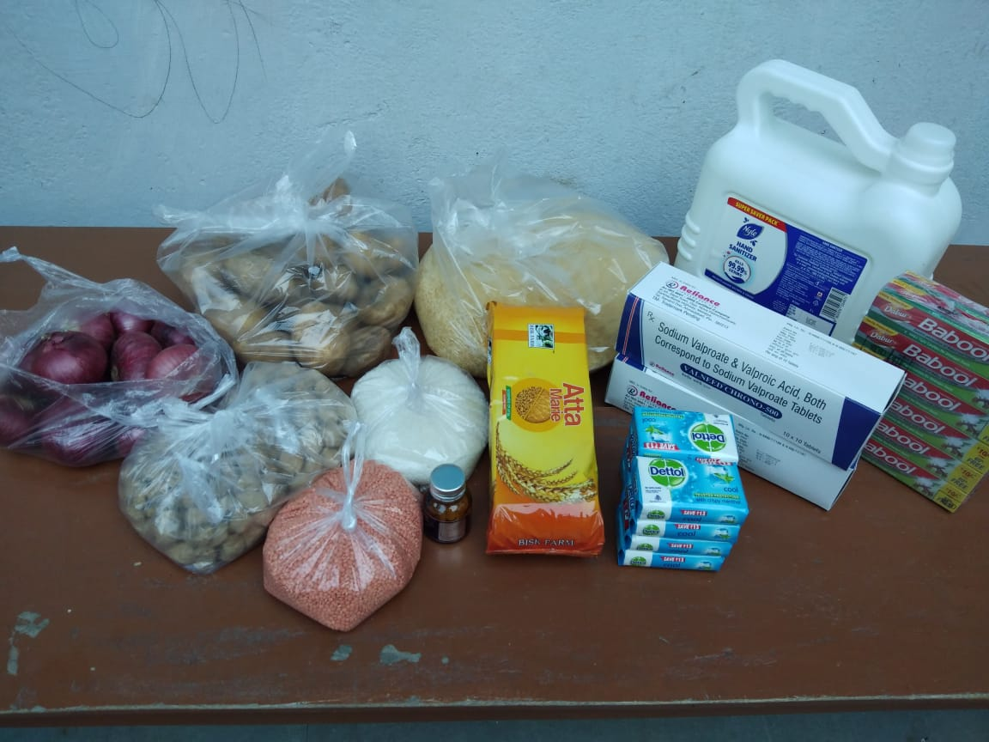  Inhalt eines Paketes mit Nahrungsmitteln und Hygieneprodukten
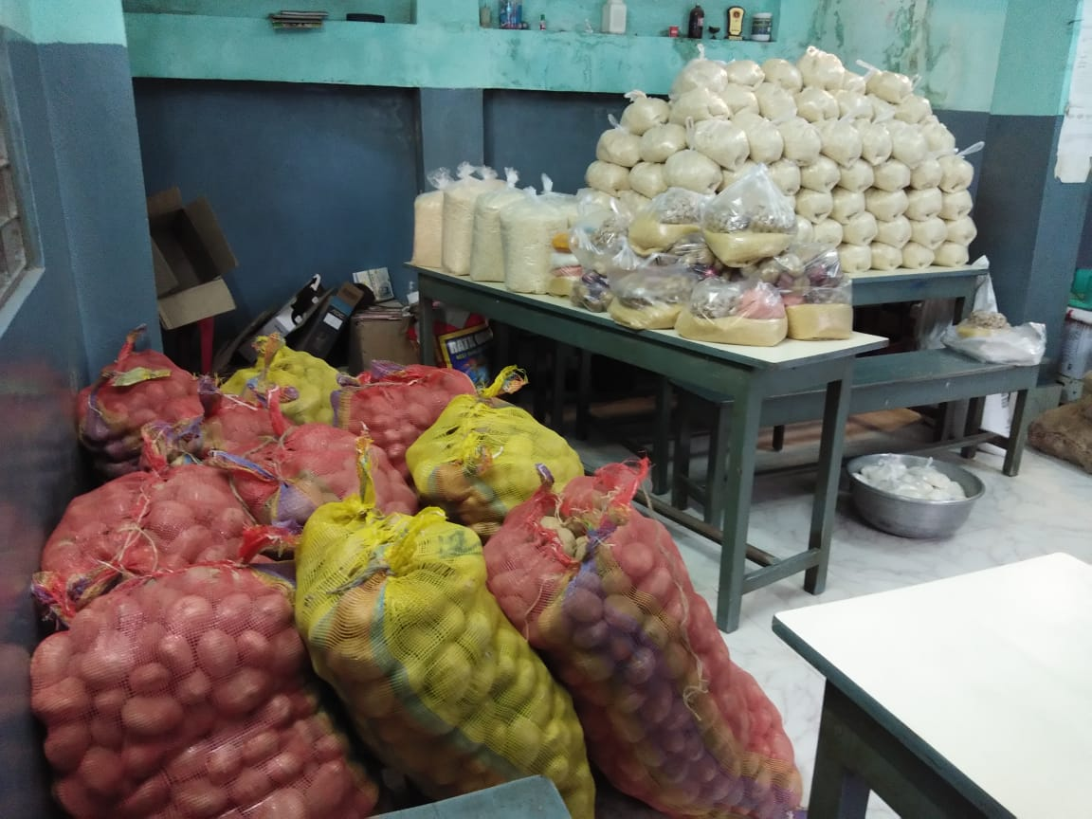  Nahrungsmittel im IIMC | 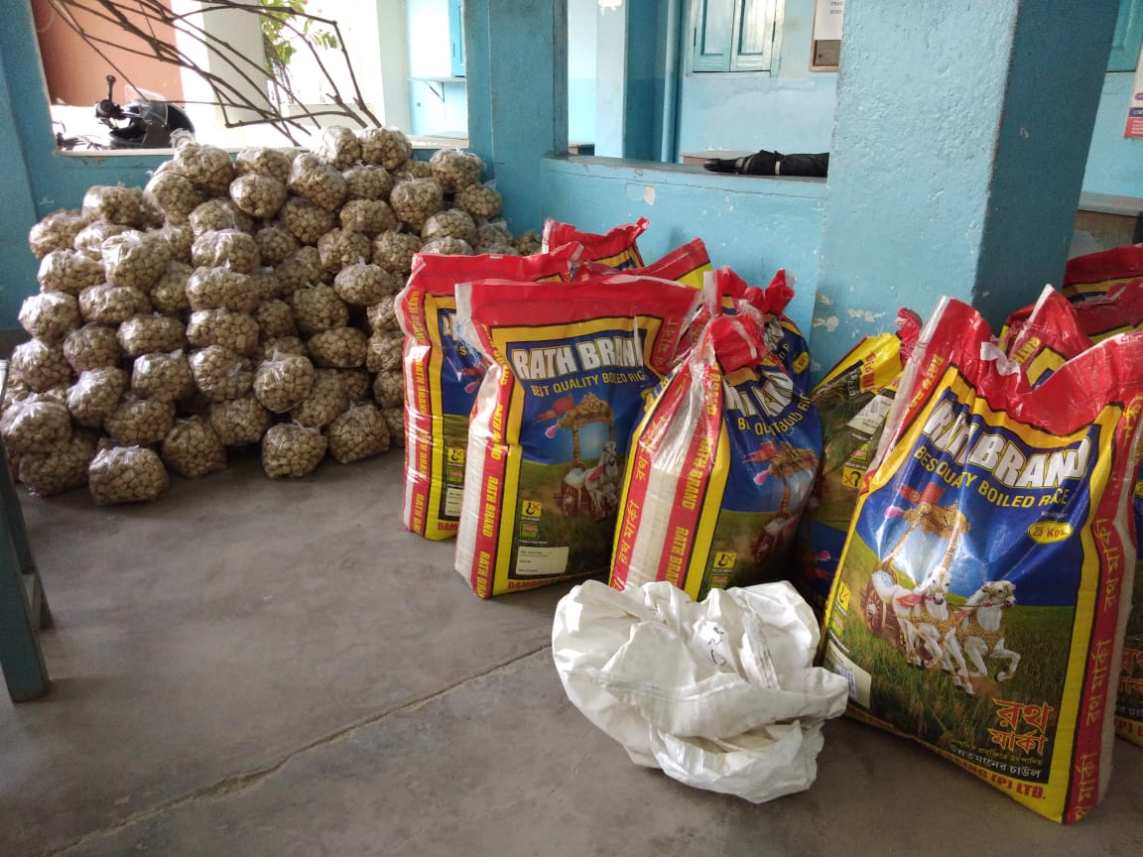  Reis und Kartoffeln in großen Mengen
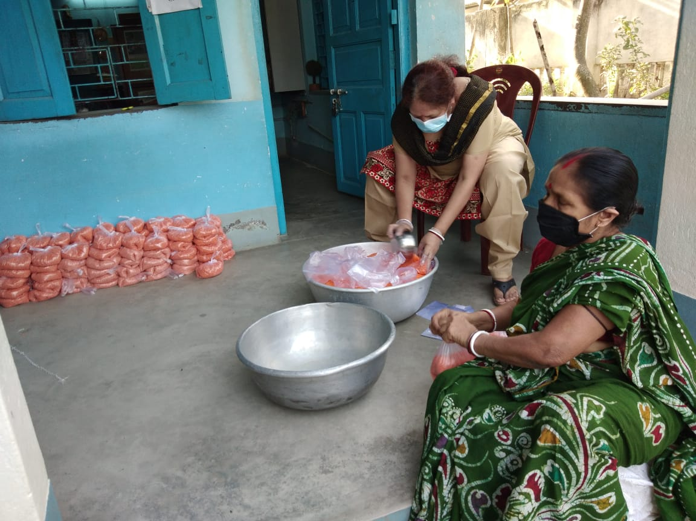  Mitarbeiterinnen des IIMC beim Verpacken der Nahrung | 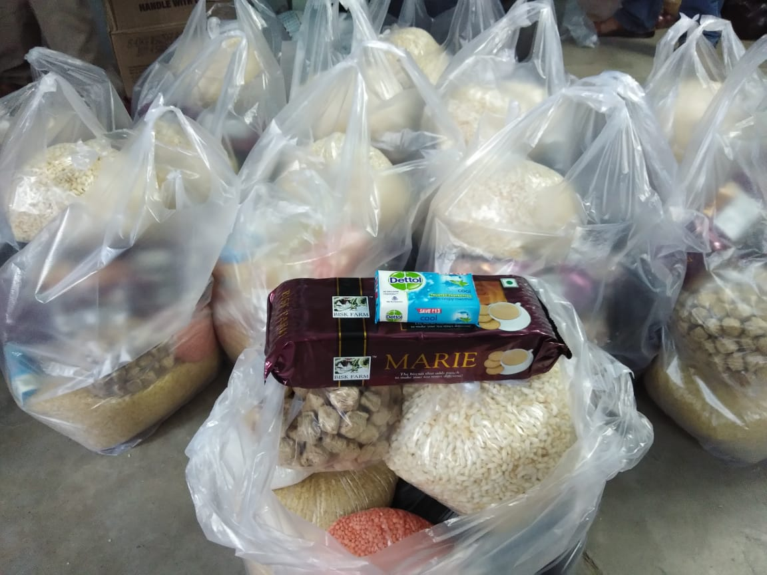  Fertig gepackte Versorgungstüten

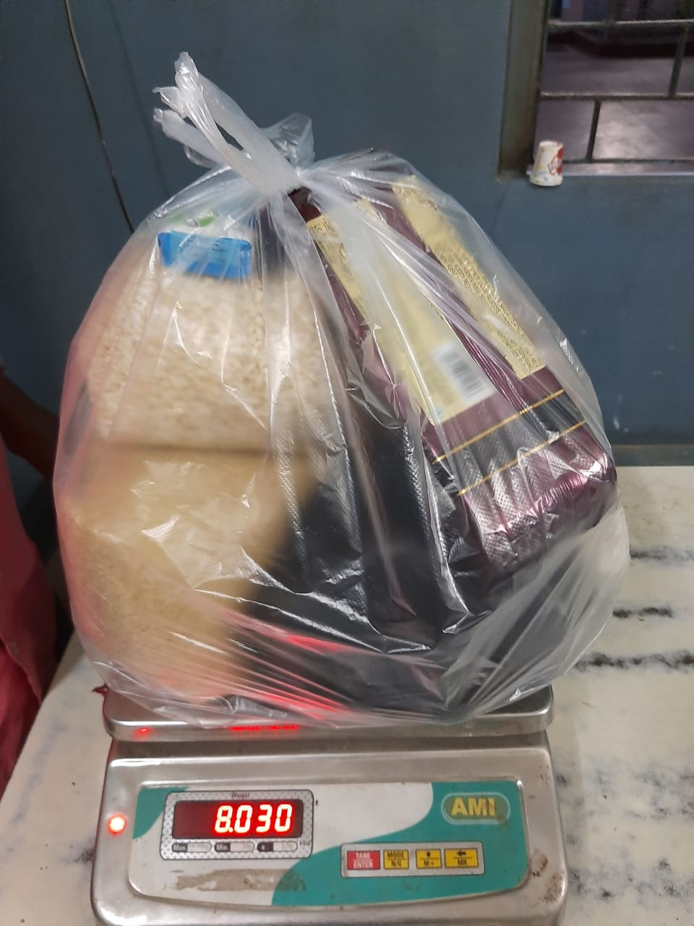  Das fertige Hilfspaket auf der Waage | 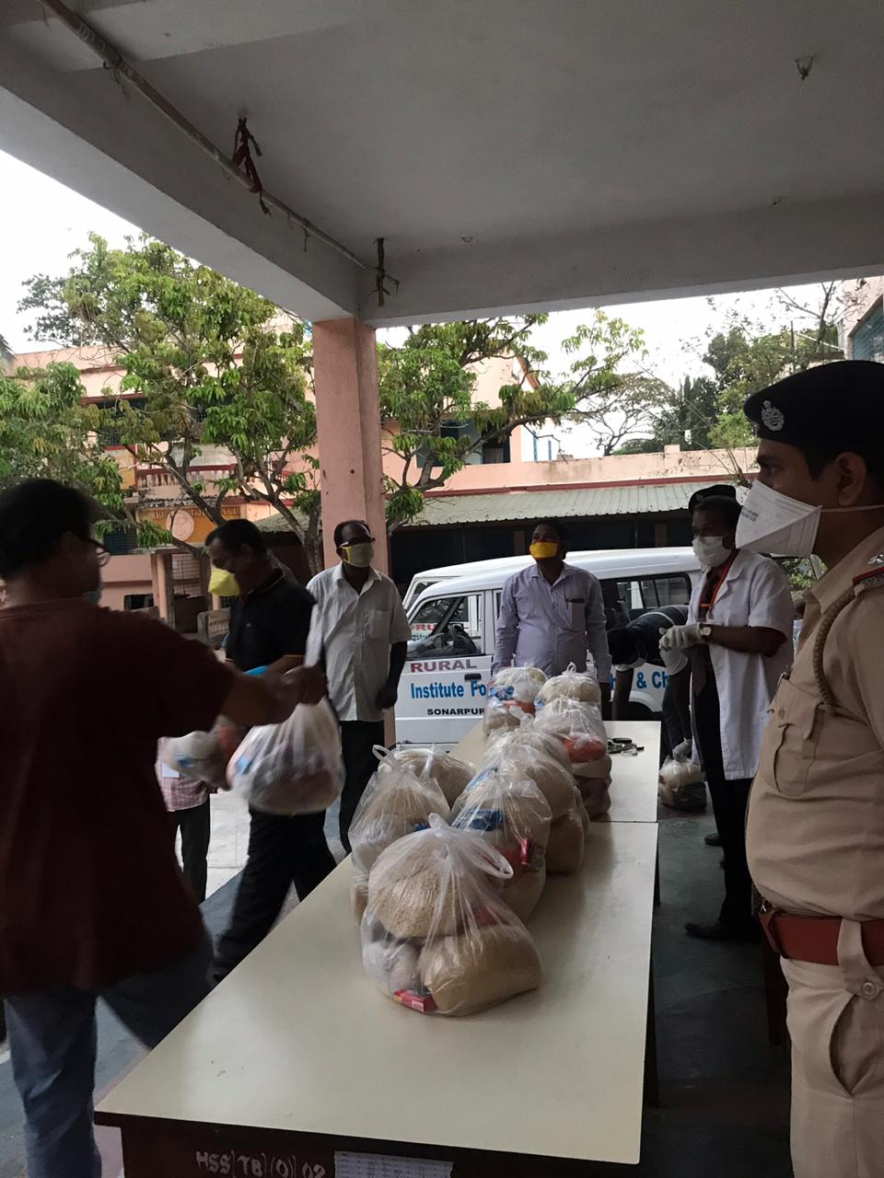  Ausgabestelle für Notrationen an Bedürftige
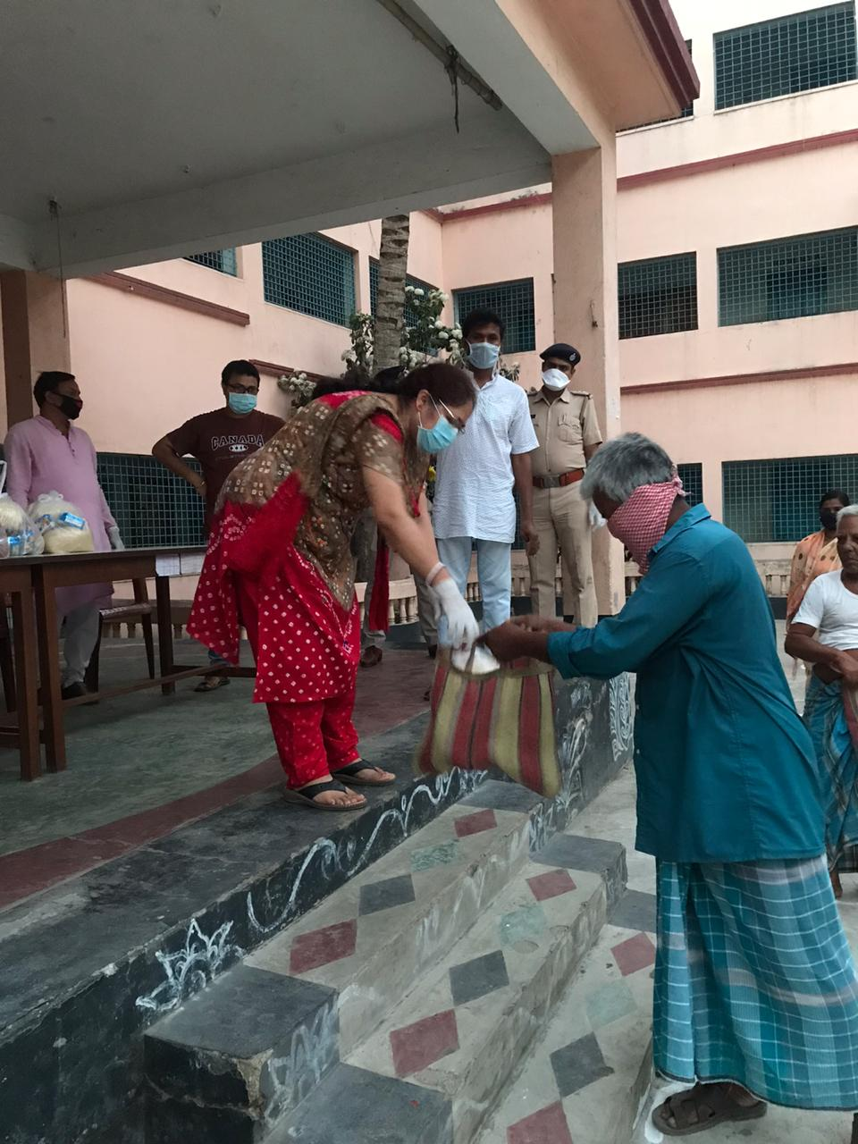  Mitarbeiter bei der Ausgabe von Lebensmitteln und Hygieneprodukten | 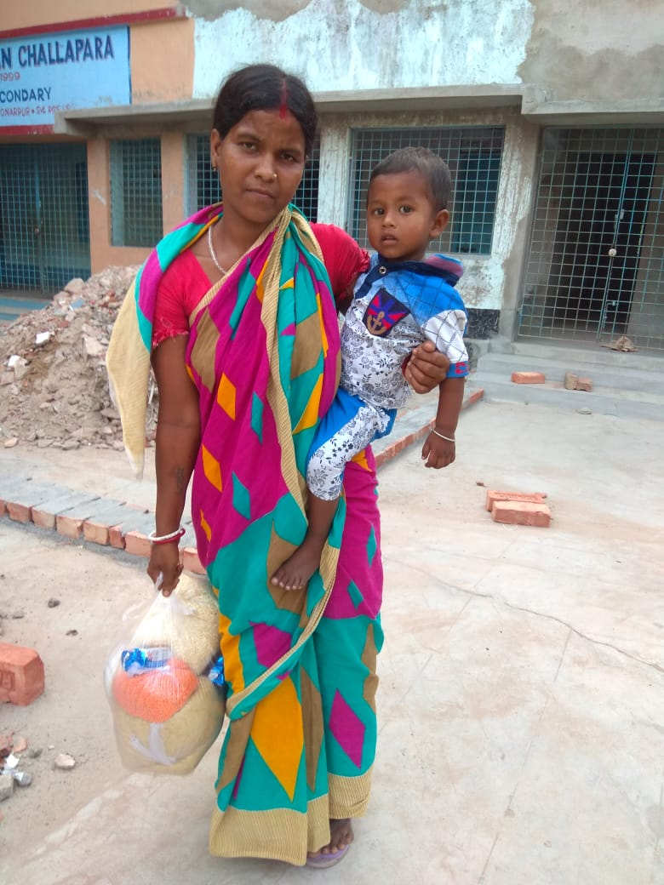  Eine Frau und ihr Kind bekommen Nahrungsmittel vom IIMC
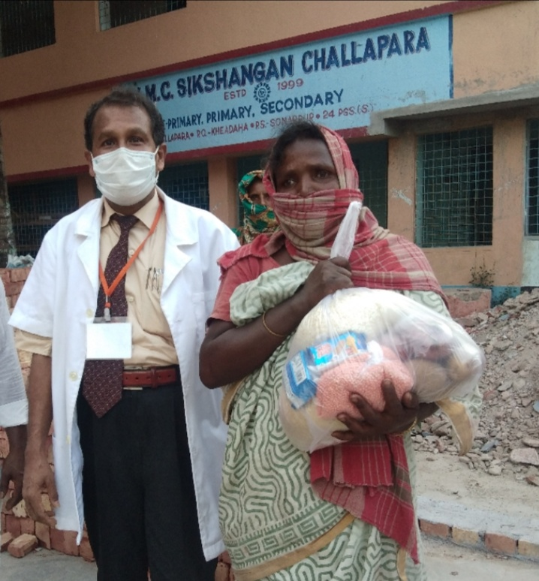 | 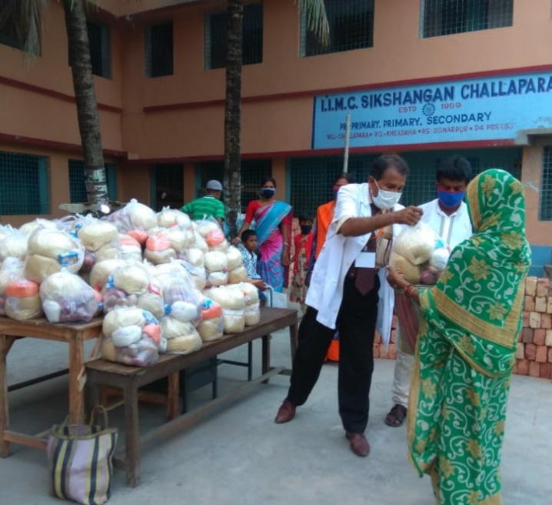
Dr. Sujit bei der Lebensmittelausgabe an einer IIMC-Schule
„Giving food to a poor mother is not doing a favour to her. It is an opportunity for us, and shall do it with pleasure.” Dr Sujit

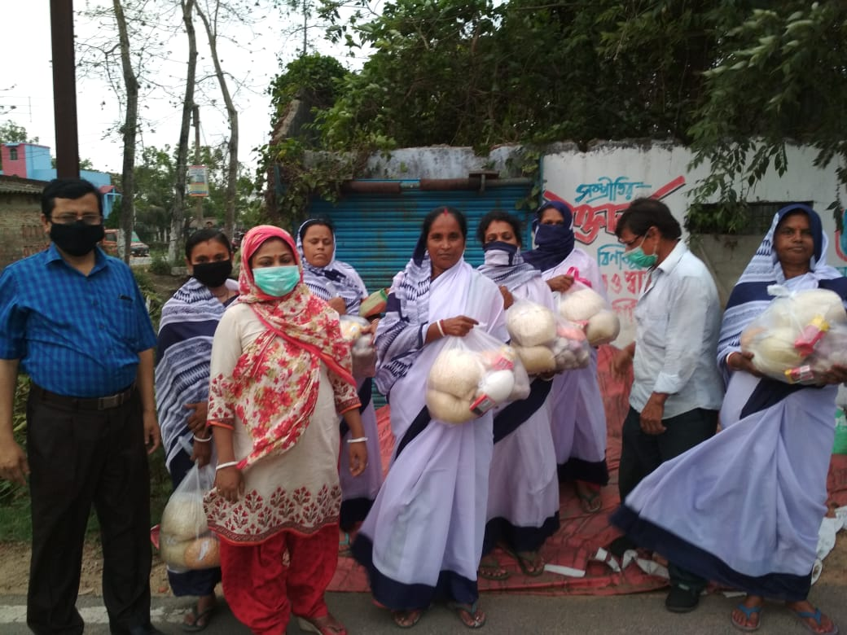  Frauen empfangen Lebensmittelpakete | 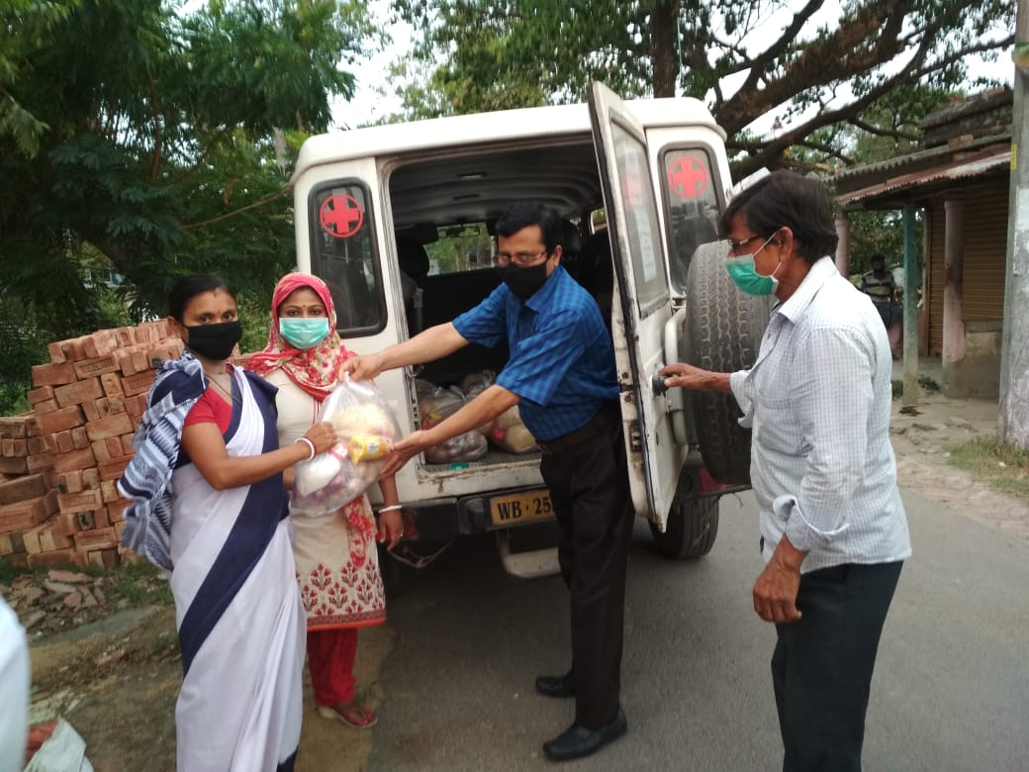  Ausgabe der Pakete aus dem IIMC-Fahrzeug
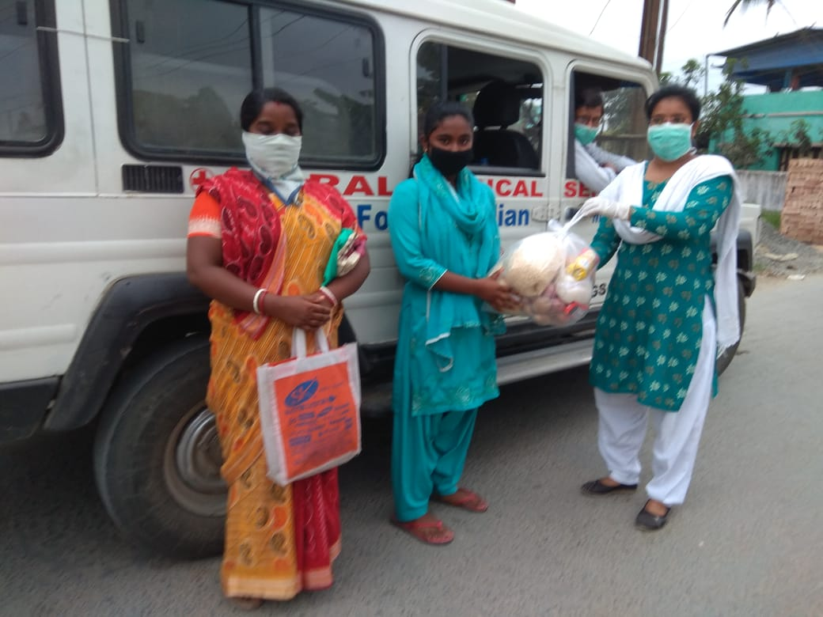 | 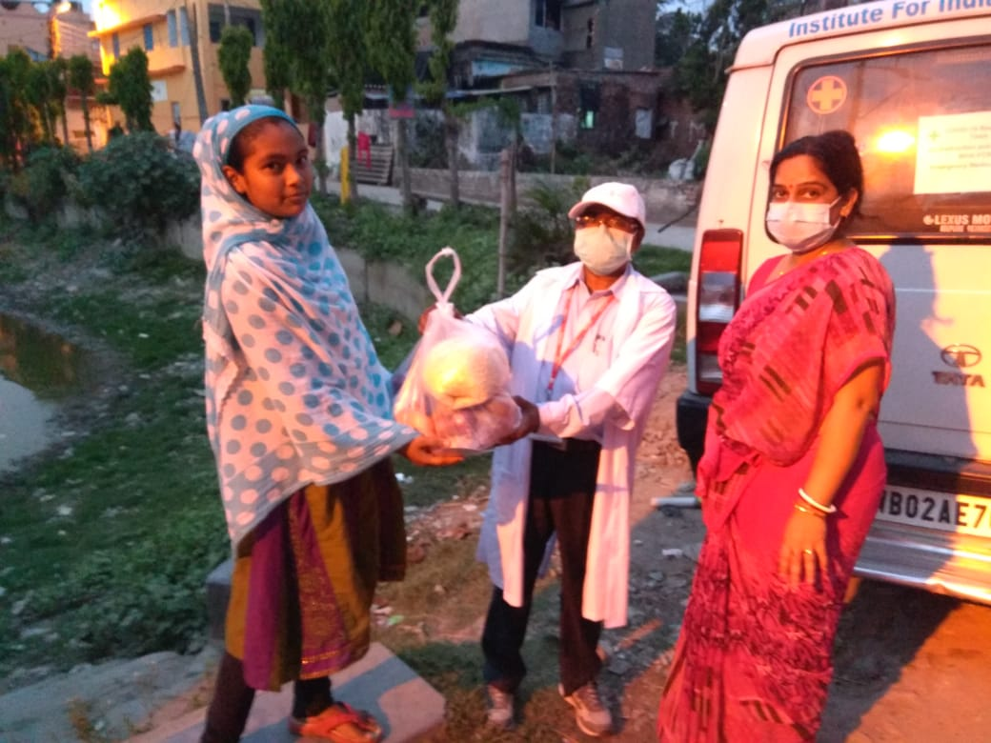
Sponsored Children des IIMC erhalten Nahrungsmittel für sich und ihre Familie

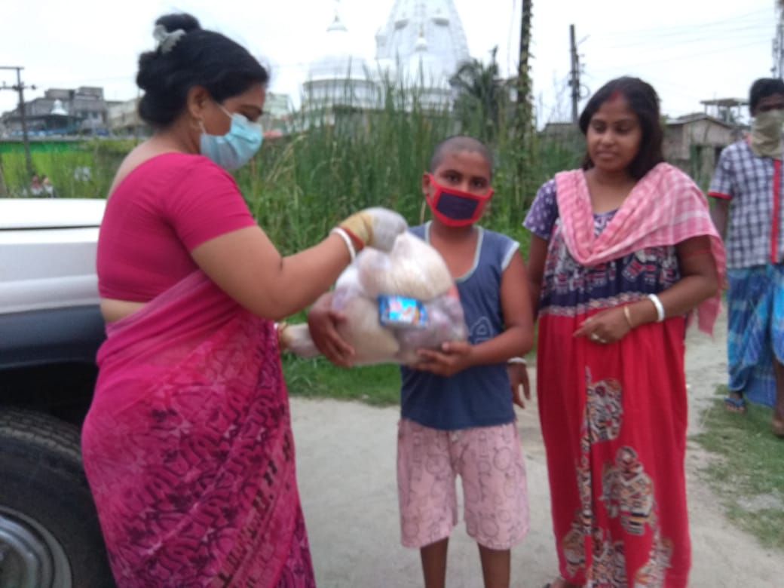  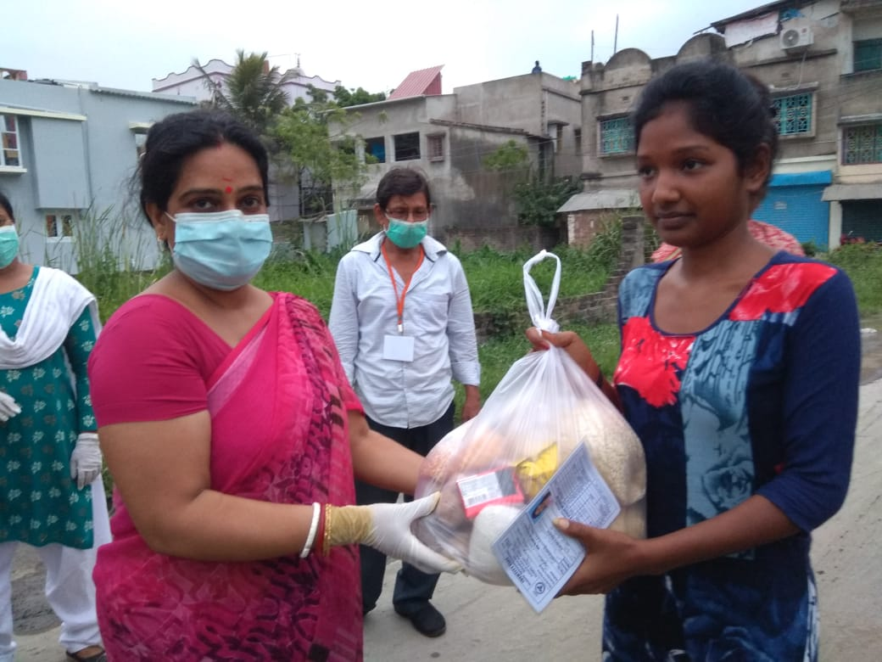 | 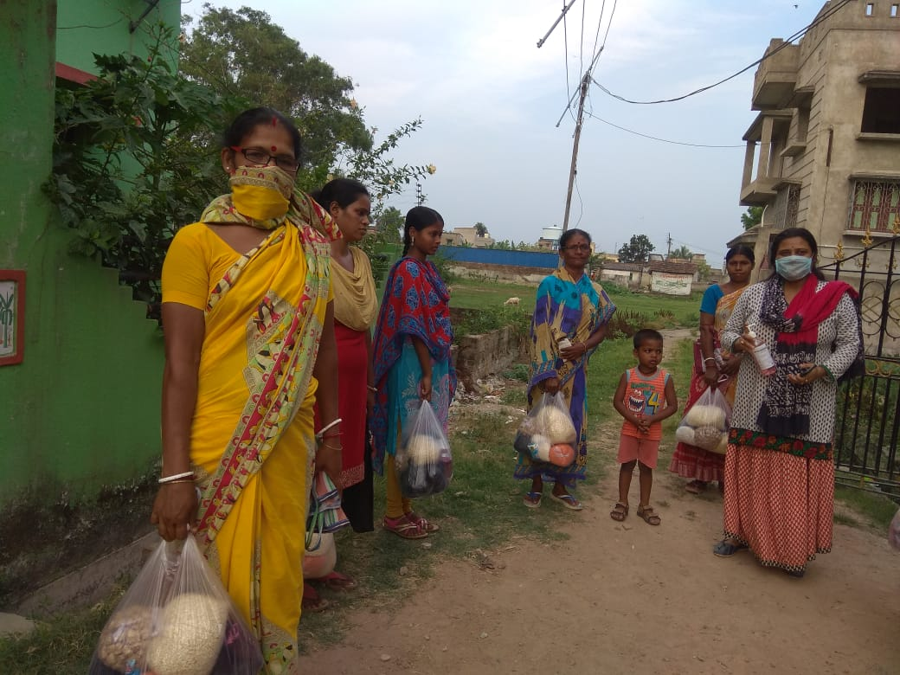  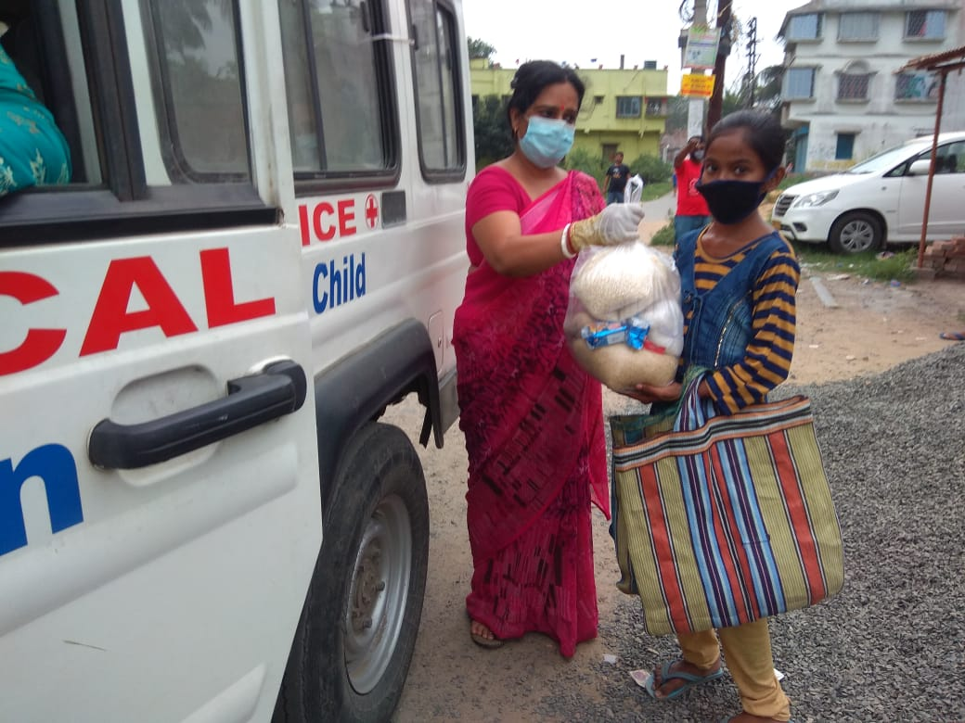

Folgend finden Sie einige Kurznachrichten von Dr. Sujit, in welchen er in den vergangenen Wochen kurze Eindrücke aus Indien schildert:

700 Rural Villages Mothers are Member of our IIMC - Women Peace Council, they have a little business with our Micro Credit loan, which is no more active because of 100% Locked Down, most of them were living on their Daily Earning - "Hands to Mouth".
They are suffering the most and even have no 2 meals in a day,
We IIMC Team have decided to help them as much possible with Food and Essential Materials for this vulnerable period.
We all hope this Catastrophic Crisis Period will be over soon, everyone will in normal life.
Thank you all for your contribution during this difficult time.
Dr Sujit.
IIMC Mission.

Churches, Mosques, Temples are closed, Universities, Colleges, Schools are off, World has shut down the doors, Doctors made Modern Temple-Hospitals will remain open, God
in the form of Doctors are working 24x7 to save lives.
Medical Scientist are in war with a sub-microscopic organism for months.
In India we are in 100% locked down for last 6 weeks.
People are suffering, struggling and Starving, we in our IIMC Mission, everyday serving food and essential commodities among poor and destitute families who was living on daily work.

Today IIMC Team, Distributed Food Packages among Educational Sponsorship Children.
Most of them are not eating 2 meals in a day, Families are Locked at Home, no work, no money, no food, IIMC Members will try to bring food for everyone.
Please forward to every sponsorship parents, and thank you all for taking care of everything.
Dr Sujit and all IIMC Team.

In our IIMC Mission, Schools, Health Centres, Mothers Banks all are Under Locked Down, Poors, Destitutes, Daily Labours have no work, have no Foods.
Everyday we are distributing 150 -160 families Food and Essential Commodities.
Today it was at our Hogalkuria Centre.
Thank you all supporting and joining us.
Dr Sujit.
IIMC Mission.

